Y45SD
Yamaha MT-09 2017-

Mounting Kit – Left Side: Mounting Kit – Right Side:
ID | Description | Cat.No | Pcs
1 | Dural. adapter SD | 537 | 1
2 | Dural. sleeve l=75 | 1236 | 1
3 | Bolt M10x130x1,25 | 905 | 1
4 | Bolt M8x25 | 815 | 2
5 | Washer M8 | 800 | 2
6 | Spring washer M10 | 801 | 1
ID | Description | Cat.No | Pcs
1 | Dural. adapter SD | 537 | 1
2 | Dural. sleeve l=53 | 1235 | 1
3 | Bolt M10x110x1,25 | 928 | 1
4 | Bolt M8x25 | 815 | 2
5 | Washer M8 | 800 | 2
6 | Spring washer M10 | 801 | 1
Mounting - Left Side:
- Remove original bolts from the frame.
- Thread the M10 washer ID.6 and dural. sleeve ID.2 on the bolt ID.3. Sleeve ID.2 by mounting in the frame.
- Install this assembly into the motorcycle frame.
- Mount the slider using M8 bolts ID.4 and washers ID.5

Mounting - Right Side:
- Remove original bolts from the frame.
- Thread the M10 washer ID.6 and dural. sleeve ID.2 on the bolt ID.3. Sleeve ID.2 by mounting in the frame.
- Install this assembly into the motorcycle frame.
- Mount the slider using M8 bolts ID.4 and washers ID.5.

Warning! We recommend using medium strength thread glue (blue) during assembly.
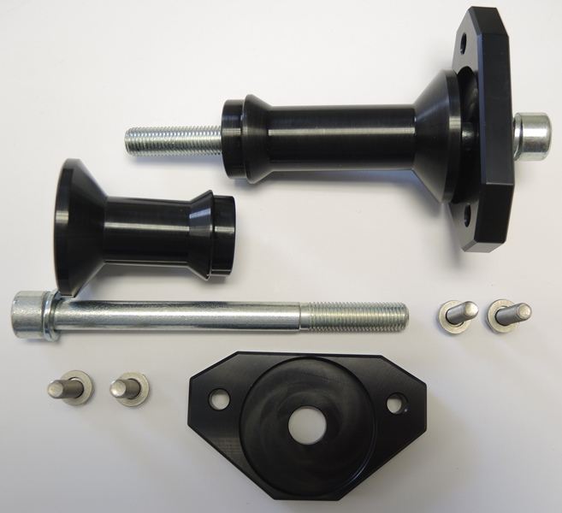
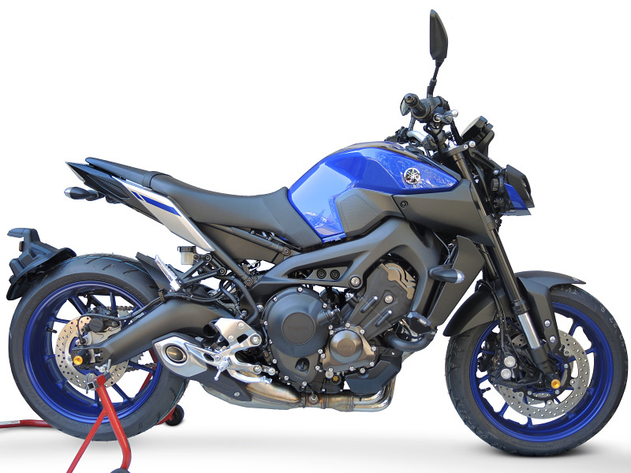
1
2
3
4
5
6

