Y45S
Yamaha MT-09 2017-

Mounting kit - Left Side: Mounting Kit – Right Side:
ID | Description | Cat.No | Pcs
1 | Dural.SL adapter d=73 | 360 | 1
2 | Bolt M10x105x1,25 | 893 | 1
3 | Bolt M6x25 | 877 | 3
4 | Bolt M4x16 | 876 | 2
ID | Description | Cat.No | Pcs
1 | Dural.SL adapter d=63 | 337 | 1
2 | Bolt M10x95x1,25 | 927 | 1
3 | Bolt M6x25 | 877 | 3
4 | Bolt M4x16 | 876 | 2

Mounting Instructions Left Side:
- Unscrew original bolt from frame.
- Equip ID.2 bolt with ID.1 dural. adapter so that it faces the frame.
- Mount this assembly onto the frame.
- Finally, use ID.3 bolts to fix the slider and ID.4 bolts to fix the dural. plate.

Mounting Instructions Right Side:
- Unscrew original bolt from frame.
- Equip ID.2 bolt with ID.1 dural. adapter so that it faces the frame.
- Mount this assembly onto the frame.
- Finally, use ID.3 bolts to fix the slider and ID.4 bolts to fix the dural. plate.

Note: We recommend using thread glue during assembly.
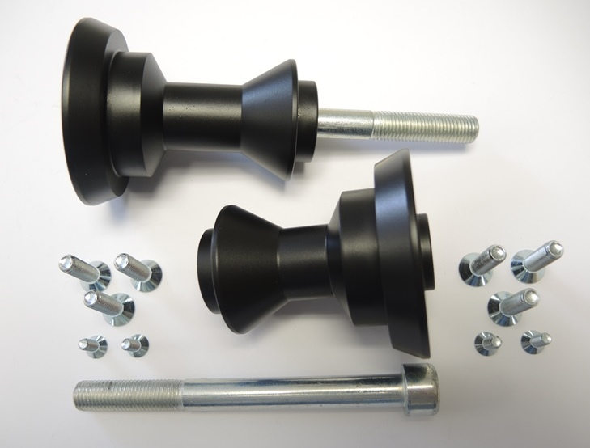
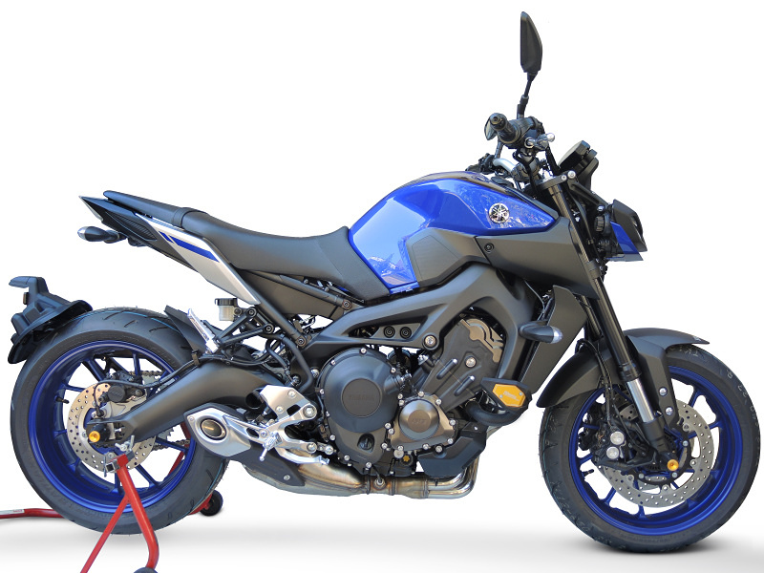
1
2
3
4

