Y46SDM
Yamaha MT-09_2018-

Kit for the Left Side |  |  |  |  | Kit for the Right Side
ID. | Description | Cat.no. | Pcs. |  |  | ID. | Description | Cat.no. | Pcs.
1 | Steel Adapter (shorter) | 736 | 1 |  |  | 1 | Steel adapter (longer) | 737 | 1
2 | Bolt M10x80x1,25 | 920 | 1 |  |  | 2 | Bolt M10x60x1,25 | 896 | 1
3 | Dural. sleeve length 25mm | 1291 | 1 |  |  | 3 | Dural. sleeve l=8mm | 1290 | 1
4 | Bolt M10x75x1,25 | 938 | 1 |  |  | 4 | Bolt M10x85x1,25 | 934 | 1
5 | Dural. sleeve l=20 mm | 1292 | 1 |  |  | 5 | Dural. sleeve l=28mm | 1289 | 1
6 | Dural. insert for hex | X115 | 2 |  |  | 6 | Dural. insert for hex | X115 | 2
7 | Bolt M10x70 | 851 | 1 |  |  | 7 | Bolt M10x70 | 851 | 1
8 | Dural. SLD adapter l=40mm | 12 | 1 |  |  | 8 | Dural. SLD adapter l=40mm | 12 | 1
9 | Bolt M6x20 | 1024 | 2 |  |  | 9 | Bolt M6x20 | 1024 | 2
10 | Washer M6 | 1023 | 2 |  |  | 10 | Washer M6 | 1023 | 2
11 | Plastic cap M10 | X4 | 2 |  |  | 11 | Plastic cap M10 | X4 | 2
12 | Adapter SLDM | 537/B | 1 |  |  | 12 | Adapter SLDM | 537/B | 1
13 | Spring washer M10 | 801 | 1 |  |  | 13 | Spring washer M10 | 801 | 1

Mounting instructions:

- Mount the Left and Right slider in the bracket according the photo below
- First attach the steel adapter to the one side, when finished to the other side and finally mount the sliders

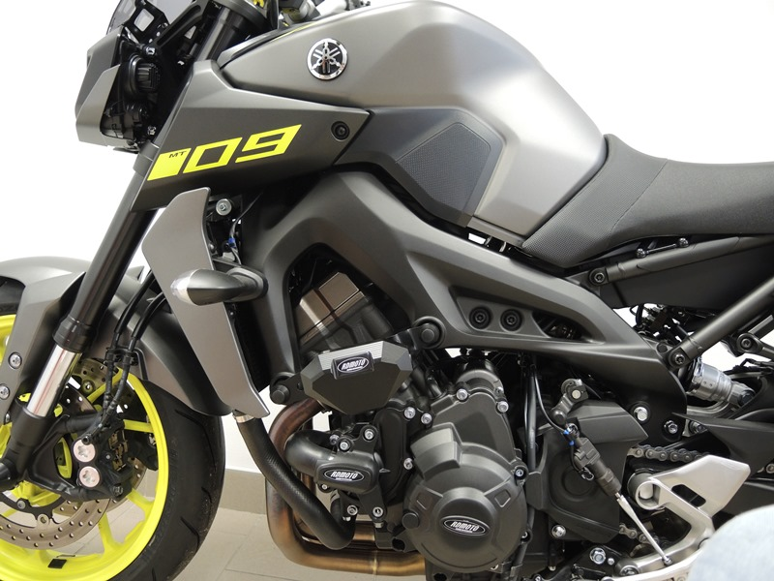
Note – we recommend using medium strength (blue) safety glue on the threads of all screws.

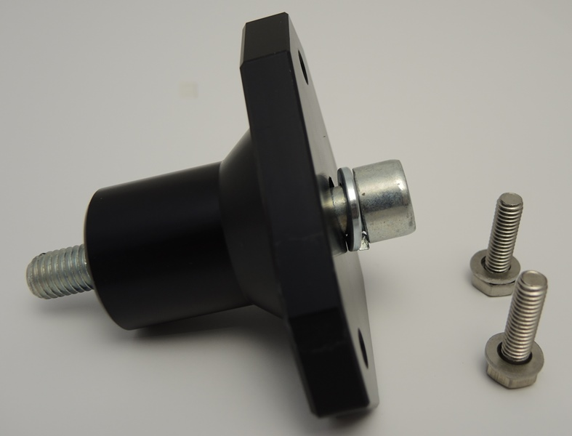
13
12
7
9

8
10

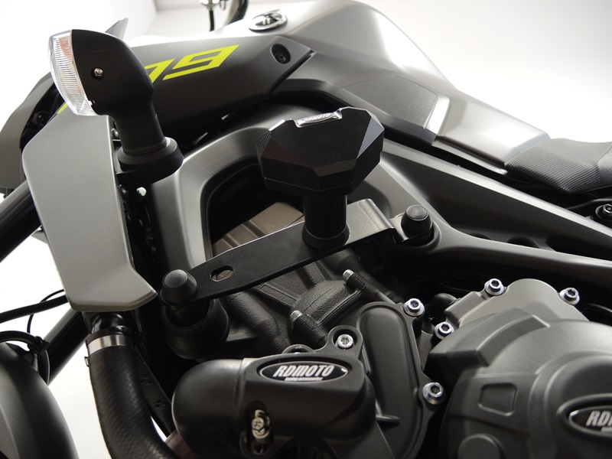
Steel Adapter ID.1 + bolt M10 ID.7 + SLD adapter ID.8 + bolt M6 ID.9 + washer M6 ID.10 + spring washer M10

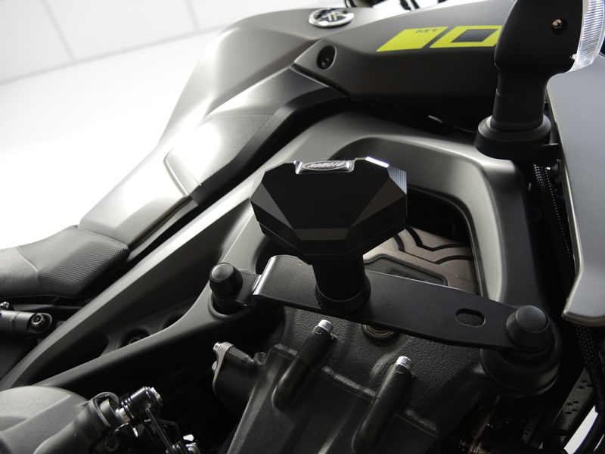
Bolt M10 ID.4 + dural. insert ID.6 + dural. sleeve ID.5 + plastic cap ID.11
Bolt M10 ID.2 + dural. insert ID.6 + dural. sleeve ID.3 + plastic cap ID.11
Bolt M10 ID.4 + dural. insert ID.6 + dural. sleeve ID.5 + plastic cap ID.11

Bolt M10 ID.2 + dural. insert ID.6 + dural. sleeve ID.3 + plastic cap ID.11

Steel Adapter ID.1 + Bolt M10 ID.7 + SLD adapter ID.8 + Bolt M6 ID.9 + washer M6 ID.10 + spring washer M10

