Y46S
Yamaha MT-09_2018-

Kit for left side |  |  |  |  | Kit for right side
ID. | Description | Cat.No | Pcs |  |  | ID. | Description | Cat.No. | Pcs
1 | Steel Adapter(short) | 736 | 1 |  |  | 1 | Steel Adapter (long) | 737 | 1
2 | Bolt M10x80x1,25 | 920 | 1 |  |  | 2 | Bolt M10x60x1,25 | 896 | 1
3 | Dural. Sleeve d=25mm | 1291 | 1 |  |  | 3 | Dural. Sleeve d=8mm | 1290 | 1
4 | Bolt M10x75x1,25 | 938 | 1 |  |  | 4 | Bolt M10x85x1,25 | 934 | 1
5 | Dural. Sleeve d=20 | 1292 | 1 |  |  | 5 | Dural. sleeve d=28mm | 1289 | 1
6 | Dural. Allen Bolt Insertion | X115 | 2 |  |  | 6 | Dural. Allen Bolt Insertion | X115 | 2
7 | Bolt M10x30 | 882 | 1 |  |  | 7 | Bolt M10x30 | 882 | 1
8 | Dural. SL adapter d=50mm | 316 | 1 |  |  | 8 | Dural. SL adaptér d=50mm | 316 | 1
9 | Bolt M6x25 | 877 | 3 |  |  | 9 | Bolt M6x25 | 877 | 3
10 | Bolt M4x12 | 876 | 2 |  |  | 10 | Bolt M4x12 | 876 | 2
11 | Plastic cover M10 | X4 | 2 |  |  | 11 | Plastic cover M10 | X4 | 2

Mounting Instructions:

- Follow instructions on the attached photos to mount left and right slider into its bracket.
- Begin with attaching the steel adapter on one side, then the other and only then install the sliders.
Note – We recommend using medium strenght (blue) thread glue during assembly.
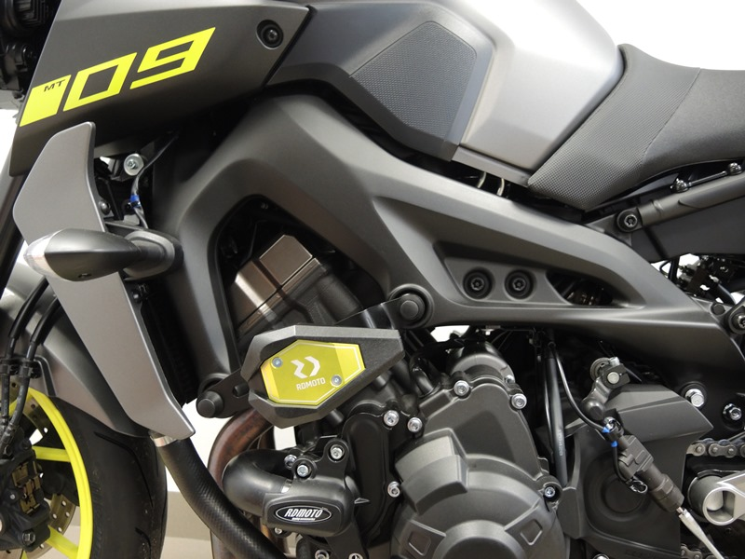

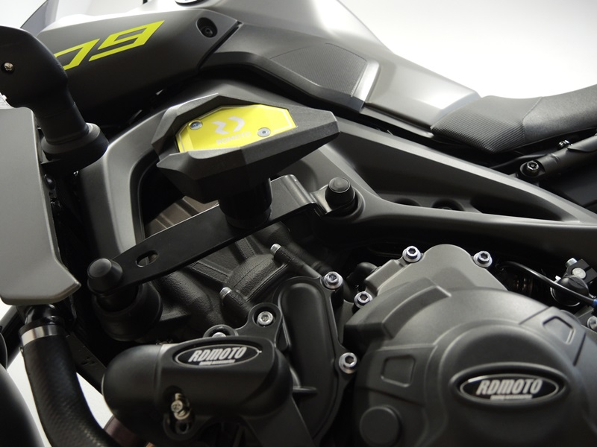
Steel adapter ID.1 + Bolt M10 ID.7 + SL adapter ID.8 + Bolt M6 ID.9 + Bolt M4 ID.10
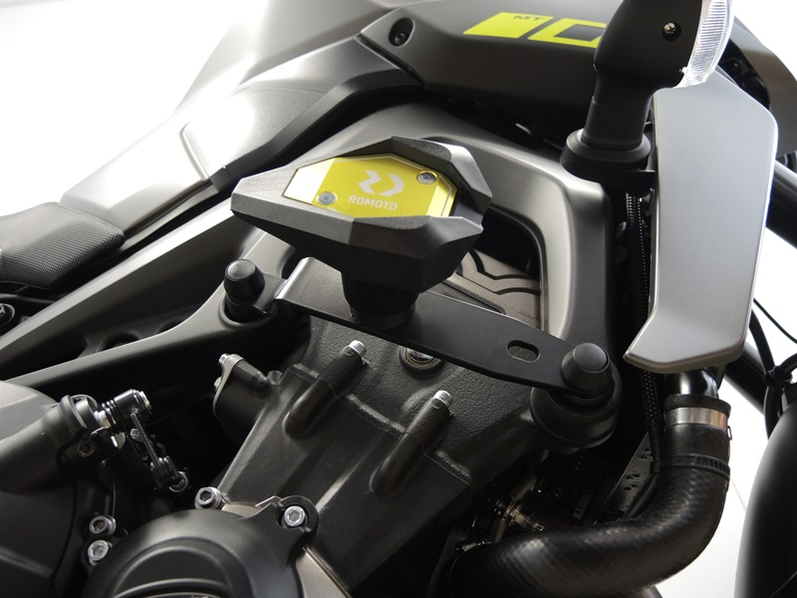
Bolt M10 ID.4 + Dural. insertion ID.6 + Dural. sleeve ID.5 + Plastic cover ID.11
Bolt M10 ID.2 + Dural. insertion ID.6 + Dural. sleeve ID.3 + Cover plastic ID.11
Bolt M10 ID.4 + Dural. insertion ID.6 + Dural. sleeve ID.5 + Plastic cover ID.11

Bolt M10 ID.2 + Dural. insertion ID.6 + Dural. sleeve ID.3 + Plastic cover ID.11

Steel adapter ID.1 + Bolt M10 ID.7 + SL adapter ID.8 + Bolt M6 ID.9 + Bolt M4 ID.10

