Y46
Yamaha MT-09_2018-

Kit for left side |  |  |  |  | Kit for right side
ID. | Description | Cat.no | Pcs |  |  | ID. | Description | Cat.no | Pcs
1 | Steel adapter (short) | 736 | 1 |  |  | 1 | Steel adapter (long) | 737 | 1
2 | Bolt M10x80x1,25 | 920 | 1 |  |  | 2 | Bolt M10x60x1,25 | 896 | 1
3 | Dural. sleeve d=25mm | 1291 | 1 |  |  | 3 | Dural. sleeve d=8mm | 1290 | 1
4 | Bolt M10x75x1,25 | 938 | 1 |  |  | 4 | Bolt M10x85x1,25 | 934 | 1
5 | Dural. sleeve d=20 | 1292 | 1 |  |  | 5 | Dural. sleeve d=28mm | 1289 | 1
6 | Dural. allen bolt insertion | X115 | 2 |  |  | 6 | Dural. allen bolt insertion | X115 | 2
7 | Bolt M10x65 | 943 | 1 |  |  | 7 | Bolt M10x65 | 943 | 1
8 | Dural. sleeve d=20mm | DV2 | 1 |  |  | 8 | Dural. sleeve d=20mm | DV2 | 1
9 | Steel insertion | X1 | 1 |  |  | 9 | Steel insertion | X1 | 1
10 | Plastic cover M10 | X4 | 2 |  |  | 10 | Plastic cover M10 | X4 | 2

Mounting Instructions:

- Follow instructions on the attached photos to mount left and right slider into its bracket.
- Begin with attaching the steel adapter on one side, then the other and only then install the sliders.
Note – We recommend using medium strenght (blue) thread glue during assembly.

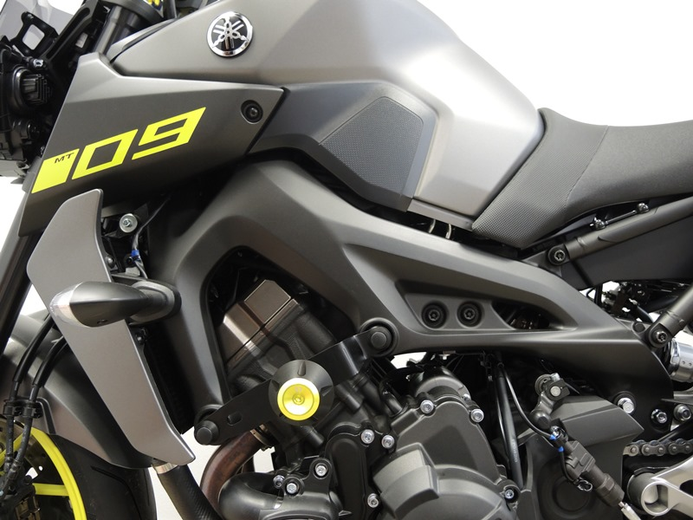

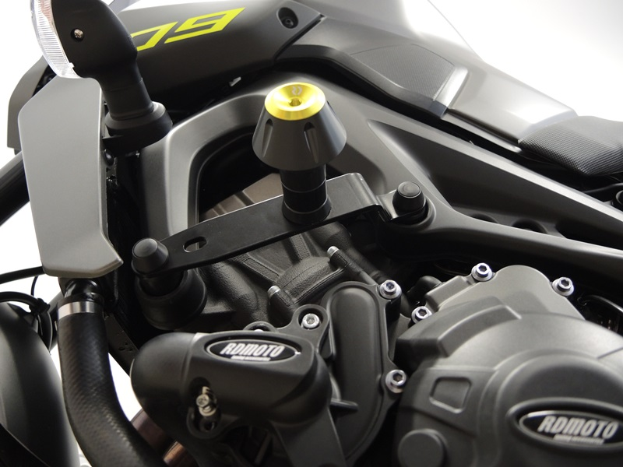
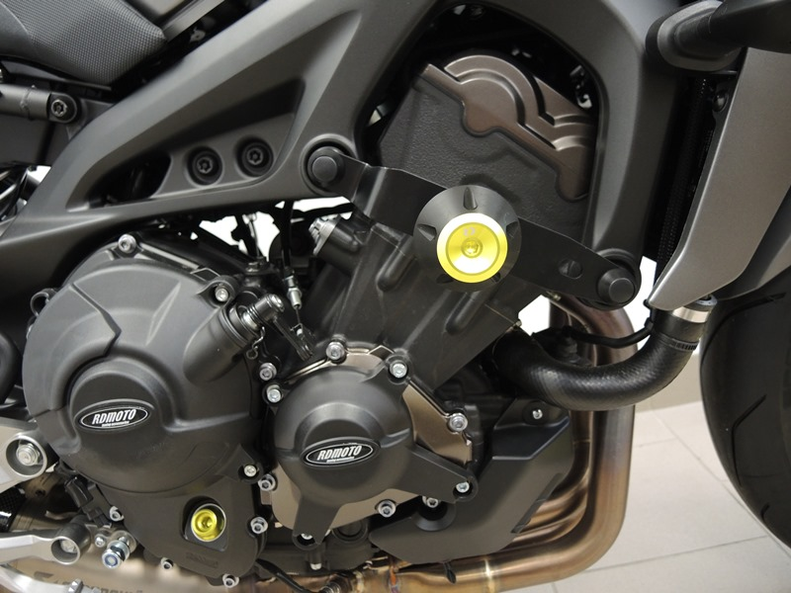
Bolt M10 ID.4 + Dural. insertion ID.6 + Dural. sleeve ID.5 + Plastic cover ID.11
Steel adapter ID.1 + Bolt M10 ID.7 + Sleeve ID.8
Bolt M10 ID.2 + Dural. insertion ID.6 + Dural. sleeve ID.3 + Plastic cover ID.11
Bolt M10 ID.4 + Dural. insertion ID.6 + Dural. sleeve ID.5 + Plastic cover ID.11

Bolt M10 ID.2 + Dural. insertion ID.6 + Dural. sleeve ID.3 + Plastic cover ID.11

Steel adapter ID.1 + Bolt M10 ID.7 + Sleeve ID.8

