Y47SD
Yamaha MT-07_2016-

Kit for the Left Side |  |  |  |  | Kit for the Right Side
ID. | Description | Cat.no. | Pcs. |  |  | ID. | Description | Cat.no. | Pcs.
1 | Steel Adapter (shorter) | 747 | 1 |  |  | 1 | Steel adapter (longer) | 748 | 1
2 | Bolt M12x90x1,25 | 931 | 1 |  |  | 2 | Bolt M10x90x1,25 | 931 | 1
3 | Dural. sleeve length 51mm | 1316 | 1 |  |  | 3 | Dural. sleeve l=46mm | 1317 | 1
4 | Bolt M10x40x1,25 | 941 | 1 |  |  | 4 | Bolt M10x40x1,25 | 941 | 1
5 | Dural. sleeve l=30mm | 11 | 1 |  |  | 5 | Dural. sleeve l=30mm | 11 | 1
6 | Dural. insert for hex M10 | X115 | 1 |  |  | 6 | Dural. insert for hex | X115 | 1
7 | Bolt M10x50 | 849 | 1 |  |  | 7 | Bolt M10x50 | 849 | 1
8 | Plastic cap M12 | X60 | 1 |  |  | 8 | Plastic cap M12 | X60 | 1
9 | Dural. insert for hex M12 | X116 | 1 |  |  | 9 | Dural. insert for hex M12 | X116 | 1
10 | Plastic cap M10 | X4 | 1 |  |  | 10 | Plastic cap M10 | X4 | 1
11 | Bolt M8x25 | 815 | 2 |  |  | 11 | Bolt M8x25 | 815 | 2
12 | Washer M8 | 800 | 2 |  |  | 12 | Washer M8 | 800 | 2
13 | Adapter SLD | 537 | 1 |  |  | 13 | Adapter SLD | 537 | 1

Mounting instructions:

- Mount the Left and Right slider in the bracket according the photo.
- First attach the steel adapter to the one side, when finished to the other side and finally mount the crash sliders.

Note – we recommend using medium strength (blue) safety glue on the threads of all screws.
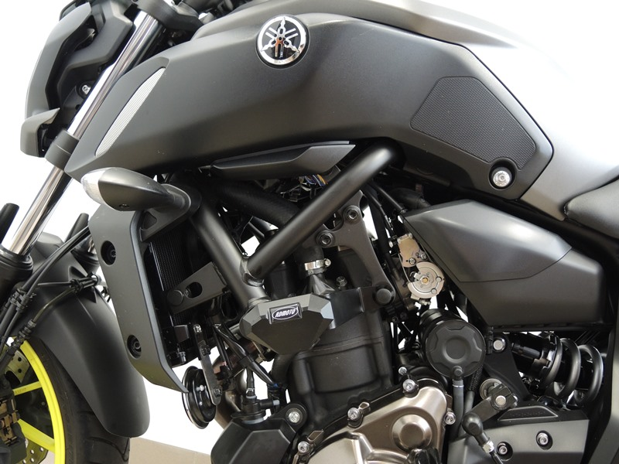

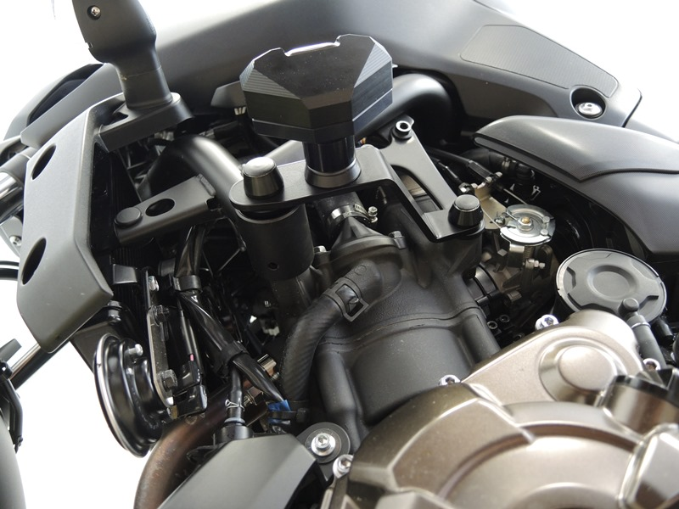
Steel Adapter ID.1 + adapter SLD ID.13 + bolt M10 ID.7 + Dural. sleeve ID.5 + bolts M8 ID.11 + washers M8 ID.12

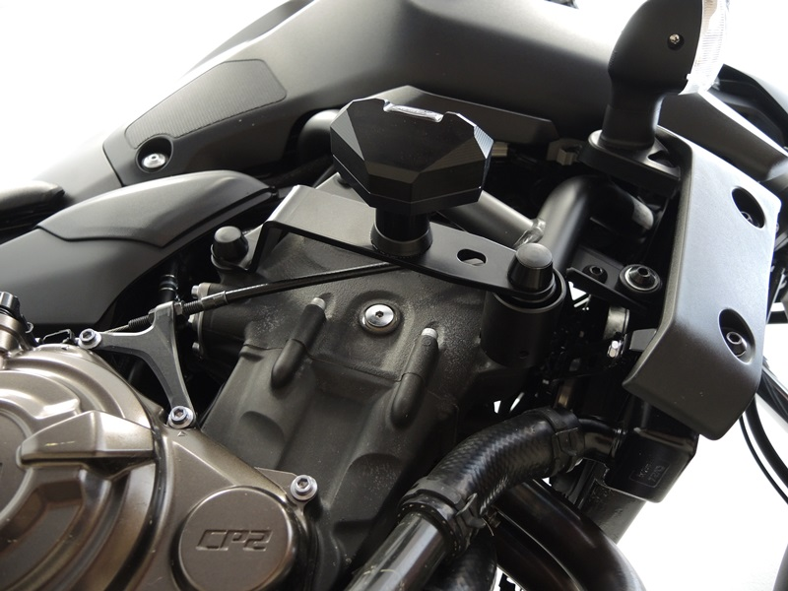
Bolt M10 ID.4 + dural. insert ID.6 + plastic cap ID.10
Bolt M10 ID.2 + dural. insert ID.9 + dural. sleeve ID.3 + plastic cap ID.8
Bolt M10 ID.4 + dural. insert ID.6 + plastic cap ID.10

Bolt M12 ID.2 + dural. insert ID.9 + dural. sleeve ID.3 + plastic cap ID.8

Steel Adapter ID.1 + adapter SLD ID.13 + bolt M10 ID.7 + dural. sleeve ID.5 + bolts M8 ID.11 + washers M8 ID.12

