Y47S
Yamaha MT-07_2016-

Kit for the Left Side |  |  |  |  | Kit for the Right Side
ID. | Description | Cat.no. | Pcs. |  |  | ID. | Description | Cat.no. | Pcs.
1 | Steel adapter(shorter) | 747 | 1 |  |  | 1 | Steel adapter(longer) | 748 | 1
2 | Bolt M12x90x1,25 | 931 | 1 |  |  | 2 | Bolt M10x90x1,25 | 931 | 1
3 | Dural. sleeve length 51mm | 1316 | 1 |  |  | 3 | Dural. sleeve d=46mm | 1317 | 1
4 | Bolt M10x40x1,25 | 941 | 1 |  |  | 4 | Bolt M10x40x1,25 | 941 | 1
5 | Dural. sleeve | 317 | 1 |  |  | 5 | Dural. sleeve | 317 | 1
6 | Dural. insert for hex M10 | X115 | 1 |  |  | 6 | Dural. insert for hex M10 | X115 | 1
7 | Bolt M10x20 | 819 | 1 |  |  | 7 | Bolt M10x20 | 819 | 1
8 | Plastic cap M12 | X60 | 1 |  |  | 8 | Plastic Cap M12 | X60 | 1
9 | Dural. insert for hex M12 | X116 | 1 |  |  | 9 | Dural. insert for hex M12 | X116 | 1
10 | Plastic cap M10 | X4 | 1 |  |  | 10 | Krytka plastová M10 | X4 | 1
11 | Bolt M6x25 | 877 | 3 |  |  | 11 | Šroub M6x25 | 877 | 3
12 | Bolt M4x16 | 876 | 2 |  |  | 12 | Šroub M4x16 | 876 | 2

Mounting instructions:

- Mount the Left and Right slider in the bracket according the photo below.
- First attach the steel adapter to the one side, when finished to the other side and finally mount the crash protectors.

Note – we recommend using medium strength (blue) safety glue on the threads of all screws.

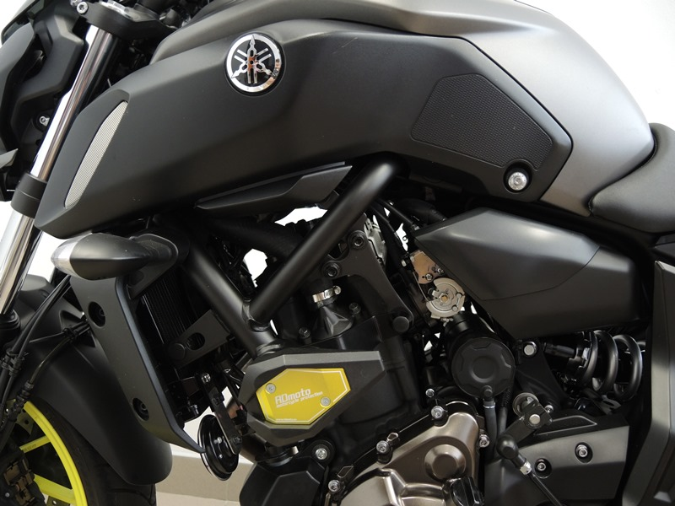

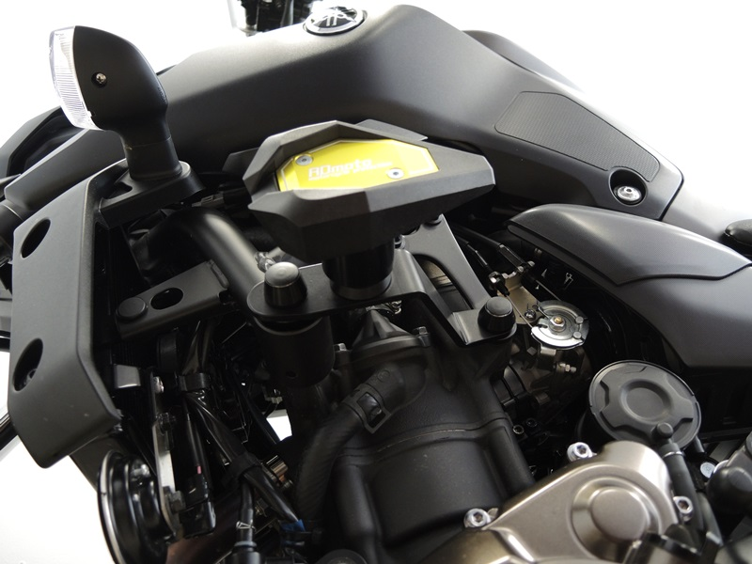

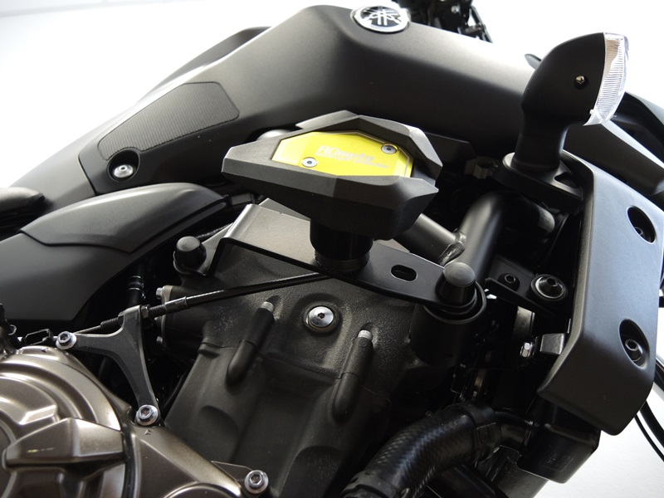
Bolt M10 ID.4 + dural. insert ID.6 + plastic cap ID.10
Steel Adapter ID. 1 + Bolt M10 ID.7 + sleeve ID.5 + Bolts M6 ID.11 + Bolts M4 ID.12
Bolt M10 ID.2 + dural. insert ID.9 + dural. sleeve ID.3 + plastic cap ID.8
Bolt M10 ID.4 + dural. insert ID.6 + plastic cap ID.10

Bolt M12 ID.2 + dural. insert ID.9 + dural. sleee ID.3 + plastic cap ID.8

Steel Adapter ID.1 + Bolt M10 ID.7 + sleve ID.5 + bolts M6 ID.11 + bolts M4 ID.12

