Y47
Yamaha MT-07_2016-

Kit for Left Side |  |  |  |  | Kit for Right Side
ID. | Description | Cat.No. | Pcs |  |  | ID. | Description | Cat.No | Pcs
1 | Steel adapter (short) | 747 | 1 |  |  | 1 | Steel adapter (long) | 748 | 1
2 | Bolt M12x90x1,25 | 931 | 1 |  |  | 2 | Bolt M10x90x1,25 | 931 | 1
3 | Dural. roller d=51mm | 1316 | 1 |  |  | 3 | Dural. roller d=46mm | 1317 | 1
4 | Bolt M10x40x1,25 | 941 | 1 |  |  | 4 | Bolt M10x40x1,25 | 941 | 1
5 | Steel insert | X1 | 1 |  |  | 5 | Steel insert | X1 | 1
6 | Dural. insert for Allen bolt M10 | X115 | 1 |  |  | 6 | Dural. insert for Allen bolt M10 | X115 | 1
7 | Bolt M10x35 | 847 | 1 |  |  | 7 | Bolt M10x35 | 847 | 1
8 | Plastic cover M12 | X60 | 1 |  |  | 8 | Plastic cover M12 | X60 | 1
9 | Dural. insert for Allen bolt M12 | X116 | 1 |  |  | 9 | Dural. insert for Allen bolt M12 | X116 | 1
10 | Plastic cover M10 | X4 | 1 |  |  | 10 | Plastic cover M10 | X4 | 1

Mounting Instructions:

- Proceed with installation of the slider on both sides following pictures attached.
- First, mount the steel adapter on one side. After you finish, continue with the other side and only then mount the crash protectors.

Note: We recommend using medium strenght glue for threads of all bolts (blue color).

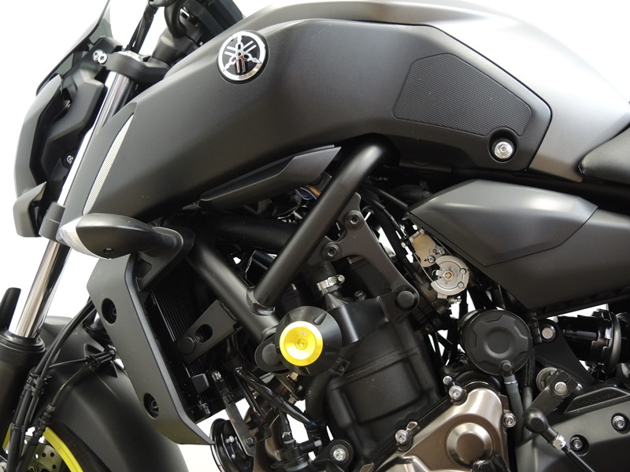

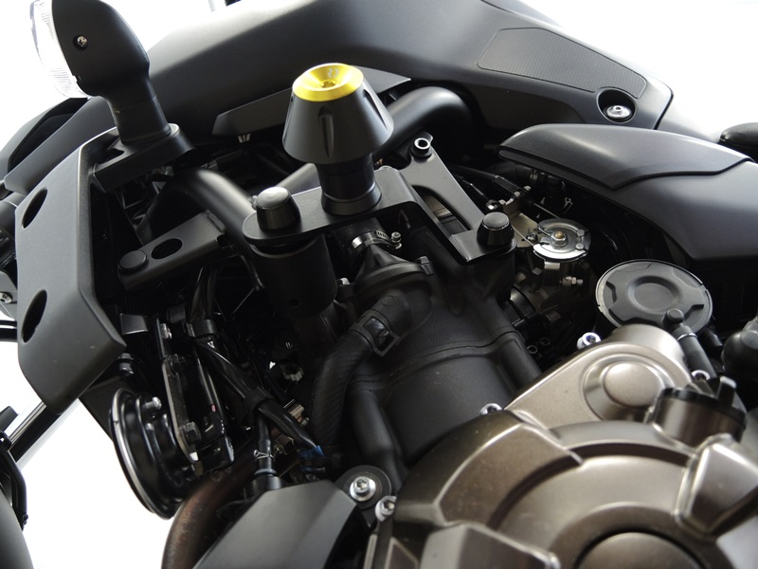
Ocel. Adaptér ID.1 + šroub M10 ID.7 .

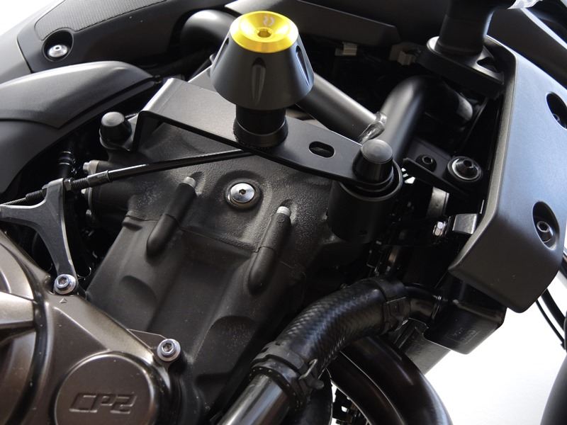
Bolt M10 ID.4 + dural. insert ID.6 + plastic cover ID.10
Bolt M10 ID.2 + dural. insert ID.9 + dural. roller ID.3 + plastic cover ID.8
Bolt M10 ID.4 + dural. insert ID.6 + plastic cover ID.10

Bolt M12 ID.2 + dural. insert ID.9 + dural. roller ID.3 + plastic cover ID.8

Steel adapter ID.1 + Bolt M10 ID.7

