3
Y48
Yamaha 700 Ténéré 2019-
Kit :
 | ID | Description |  | Cat.No | Pcs
 | 1 | AL insert M10 |  | X1 | 1
 | 2 | Bolt M10x95mm |  | 822 | 1
 | 3 | Dural. roller, lenght=30mm |  | 3 | 1
 | 4 | Nut M10 |  | 810 | 1
 | 5 | Washer M10 |  | 804 | 1
 | 6 | Crash protector |  | PH01 | 1

Mounting Instructions:
We recommend using medium strenght thread glue during assembly.

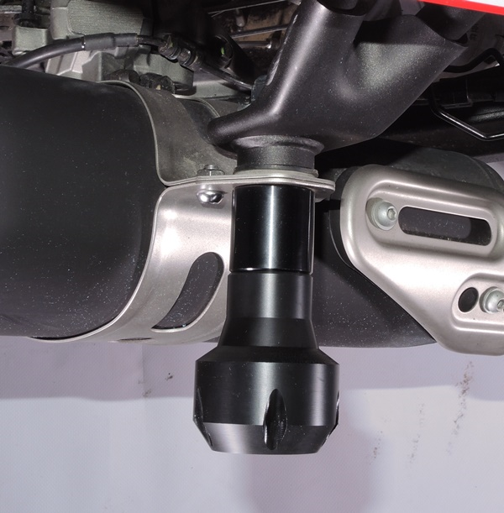
Bolt ID.2 + insert ID.1 + dural. roller. ID.3 + washer ID.5 + nut ID.4

