Y4SDM
Yamaha FZS 600 Fazer 98-03

Fitting kit left side: Fitting kit right side:

ID | Description | Cat. | Qt
1 | Dural. adapter | 581 | 1
2 | Alu. cylinder 10mm | 108 | 1
3 | Bolt M8x110 | 879 | 1
4 | Bolt M10x110 | 844 | 1
5 | Bolt cone M12x40 | 858 | 1
6 | Threaded cylinder 60mm | 237 | 1
7 | SLDM adapter | 537/B | 1
8 | Bolt M12x40 | 857 | 1
9 | Nut M10 | 810 | 1
10 | Nut M8 | 809 | 1
11 | Washer M10 | 804 | 1
12 | Washer M8 | 802 | 1
13 | Plastic cover | X4 | 1
14 | Plastic cover | X5 | 1
15 | Dural cylinder adapter | 149 | 1
16 | Bolt M6x20 | 1024 | 2
17 | Washer M6 | 1023 | 2

ID | Description | Cat. | Qt
1 | Dural. adapter | 580 | 1
2 | Alu. cylinder 10mm | 108 | 1
3 | Bolt M8x110 | 879 | 1
4 | Bolt M10x110 | 844 | 1
5 | Bolt cone M12x40 | 858 | 1
6 | Threaded cylinder 50mm | 283 | 1
7 | SLDM adapter | 537/B | 1
8 | Bolt M12x40 | 857 | 1
9 | Nut M10 | 810 | 1
10 | Nut M8 | 809 | 1
11 | Washer M10 | 804 | 1
12 | Washer M8 | 802 | 1
13 | Plastic cover | X4 | 1
14 | Plastic cover | X5 | 1
15 | Dural cylinder adapter | 149 | 1
16 | Bolt M6x20 | 1024 | 2
17 | Washer M6 | 1023 | 2
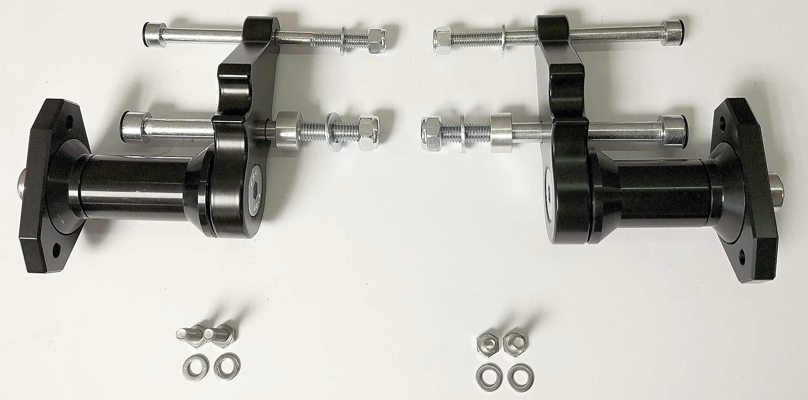
ID7
ID1
ID15
ID6

INSTRUCTIONS

- Dismantle original bolts from the frame.
- Fit threaded cylinder ID6 on the adapter ID1 using bolt ID5. Fit this kit on the frame of motorcycle using two bolts ID3 and ID4 with washers ID12 and ID11. Put cylinder ID2 on the bolt ID4. Tighten bolts from back side using nuts ID10 and ID9.
- Put SLD adapter ID7 and cylinder adapter ID15 on the bolt ID8. Mount this kit into the threaded cilinder ID6.
- Fit sliders using two bolts ID16 and washers ID17.
- Cover bolts using plastic caps ID13 and ID14.

Use medium strong glue on all threads during installation.

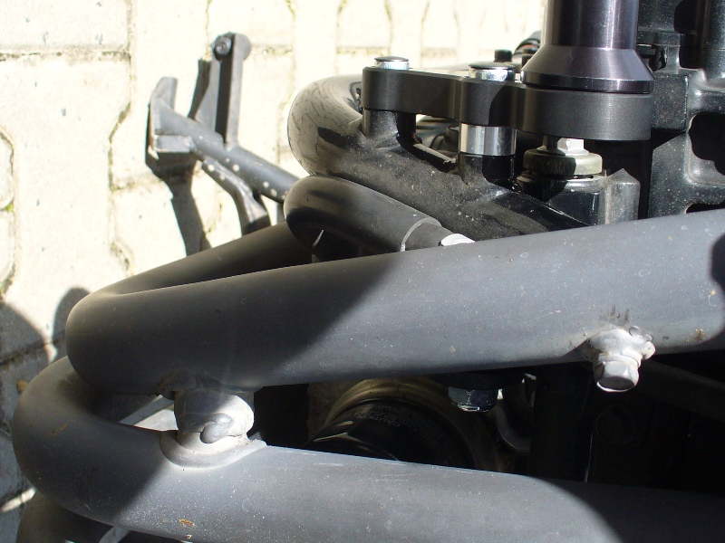
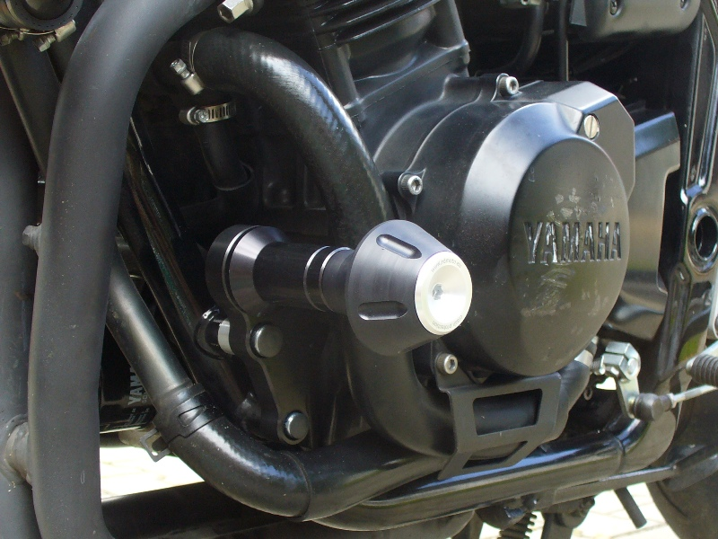
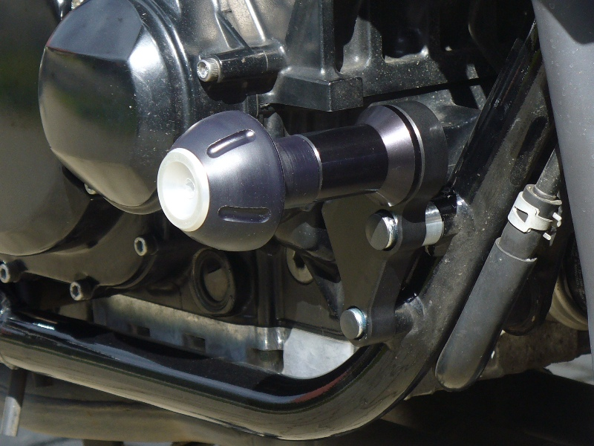
3
2
4
1

