Y4
Yamaha FZS 600 Fazer 98-03

Fitting kit left side: Fitting kit right side:

ID. | Description | Cat.N | Qt
1 | Dural. adapter | 581 | 1
2 | Spacer d=10mm | 108 | 1
3 | Bolt M8x110 | 879 | 1
4 | Bolt M10x110 | 844 | 1
5 | Bolt cone M12x40 | 858 | 1
6 | Alu spacer under protector | 237 | 1
7 | Steel box | X2 | 1
8 | Bolt M12x40 | 857 | 1
9 | Nut M10 | 810 | 1
10 | Nut M8 | 809 | 1
11 | Washer M10 | 804 | 1
12 | Washer M8 | 802 | 1
13 | Plastic cover | X4 | 1
14 | Plastic cover | X5 | 1

ID. | Description | Cat. | Qt
1 | Dural. adapter | 580 | 1
2 | Spacer d=10mm | 108 | 1
3 | Bolt M8x110 | 879 | 1
4 | Bolt M10x110 | 844 | 1
5 | Bolt cone M12x40 | 858 | 1
6 | Alu spacer under protector | 283 | 1
7 | Steel box | X2 | 1
8 | Bolt M12x40 | 857 | 1
9 | Nut M10 | 810 | 1
10 | Nut M8 | 809 | 1
11 | Washer M10 | 804 | 1
12 | Washer M8 | 802 | 1
13 | Plastic cover | X4 | 1
14 | Plastic cover | X5 | 1

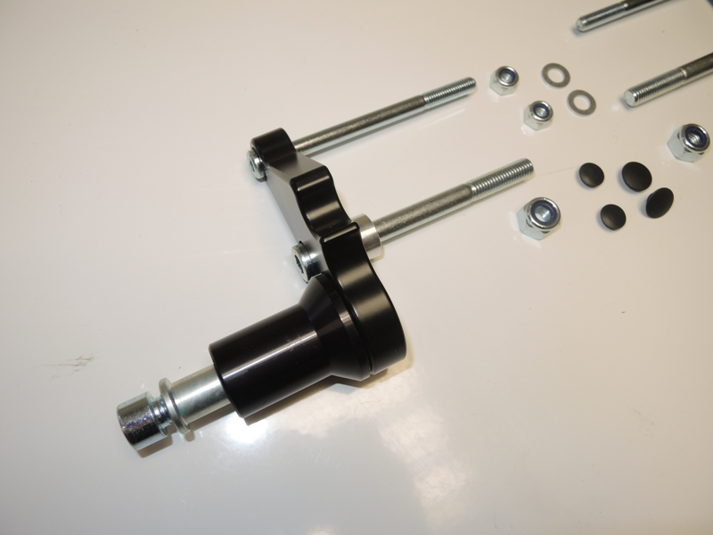

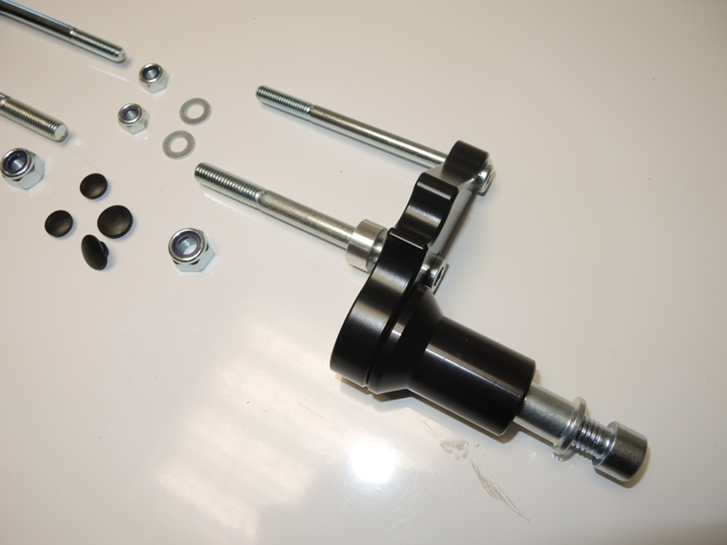
4
8
9
10
12
3
7
5
1
6
4
3
2
10
11
7
6
8
1
9
5
2

Instruction assembly:

- Assembly left and right side adapter as shown on the picture.
- Dismantle original bolts from frame. Done left side firstly.
- Assebmly ID.6 by bolts ID.5 and tighten it early than you put aluminum adapter on the bike.
- Don´t forget place alu. spacer ID.2 betewwn the frame and adapter.
- If you have mounted alu. adapter ID.1 with spacer ID.6 on the motorcycle, assembly protectors.
- Insert ID.7 into the protectors and use bolts ID.8 for tightening on the adapter.

Use medium strong glue of all threads during assembly.

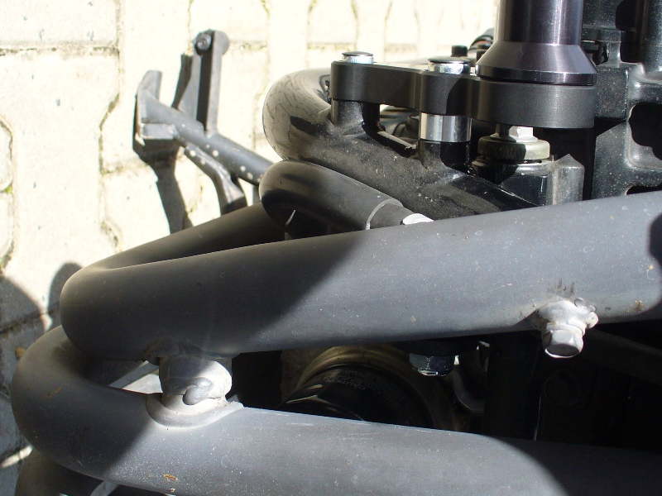
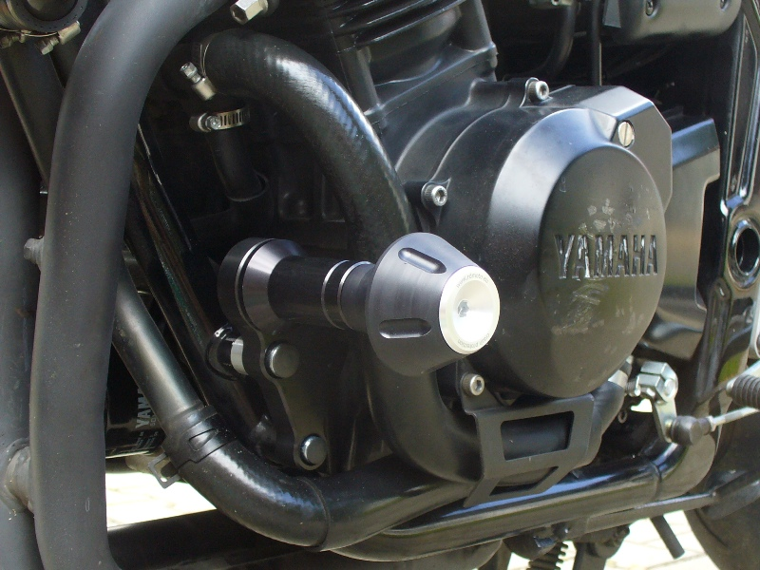
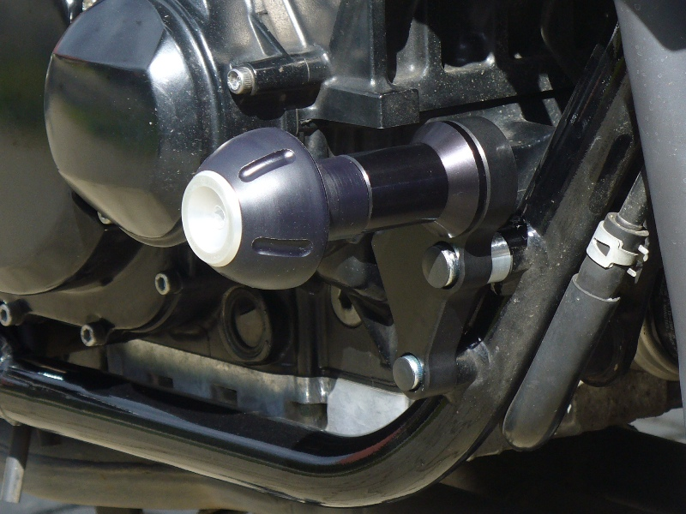
3
2
4
1

