Y5S
Yamaha FZ-6 2004-

Kit for left side: |  |  |  |  | Kit for right side:
ID | Description | Cat.n | Qt |  |  | ID | Description | Cat.n | Qt
1 | Dural.adapter for slider | DV-304 | 1 |  |  | 1 | Dural.adapter for slider | DV-304 | 1
2 | Bolt M6x25 | 877 | 3 |  |  | 2 | Bolt M6x25 | 877 | 3
3 | Bolt M4x16 | 876 | 2 |  |  | 3 | Bolt M4x16 | 876 | 2
4 | Bolt M10x75x1,25mm | 938 | 1 |  |  | 4 | Bolt M10x75x1,25mm | 938 | 1
Fitting left side:

- Take ou original bolt from frame.
- Bolt ID.4 insert into the adapter ID.1. This set mounting the place on frame.
- Place slider and tighten it by bolts ID.2.
- Place alu. cover into the slider use bolts ID.3.

Fitting right side:

- Take ou original bolt from frame.
- Bolt ID.4 insert into the adapter ID.1. This set mounting the place on frame.
- Place slider and tighten it by bolts ID.2.
- Place alu. cover into the slider use bolts ID.3.

Warning - on the threads of the screws we recommend using glue medium strong(blue).
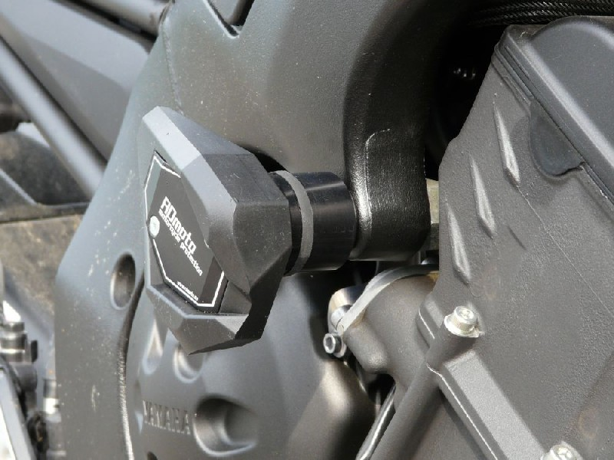
Ilustr. photos to fitting place

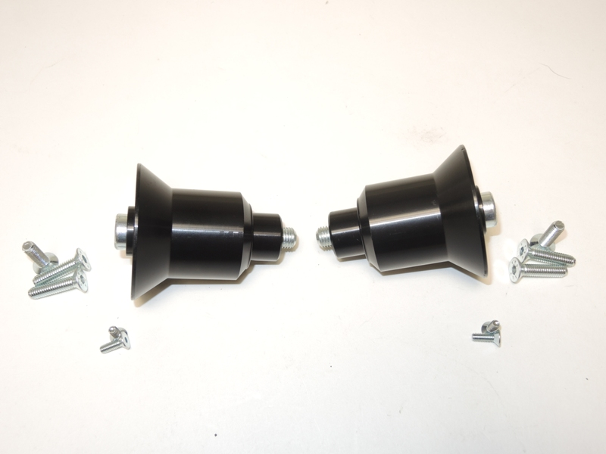
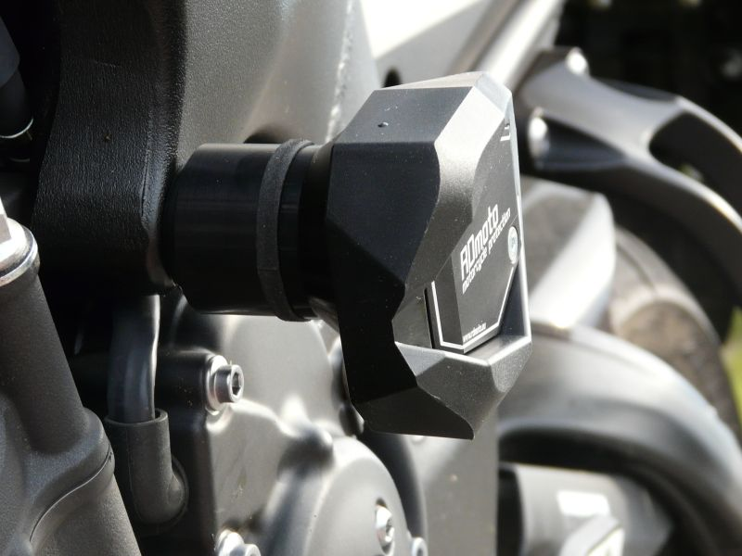

4
1
1
2
4

2

3
3

