Y7*
Yamaha YZF-R1
1998-1999

Fitting kit left side: |  |  |  |  | Fitting kit right side:
ID | Description | Cat.N | Qt |  | ID. | Description | Cat.N | Qt
1 | Steel sleeve M10 | X1 | 1 |  | 1 | Steel sleeve M12 | X2 | 1
2 | Bolt M10x115x1,25mm | 894 | 1 |  | 2 | Bolt M12x105x1,25mm | 912 | 1
3 | Spacer d=40mm | 63 | 1 |  | 3 | Spacer d=30m | 170 | 1

Assembly:

Installation of the left and right protector make to the gripping according to the attached photo above. Left side- Take off fairing from the bike and make hole. Sleeves (ID.1) insert into the protectors. Under the left protector place spacer ID.3 for assembly use bolt ID.2. Under the right protector place spacer ID.3 for assembly use bolt ID.2.

Note- during assembly use medium strong glue of all threads.
*Is necessary to drill hole into the fairing.

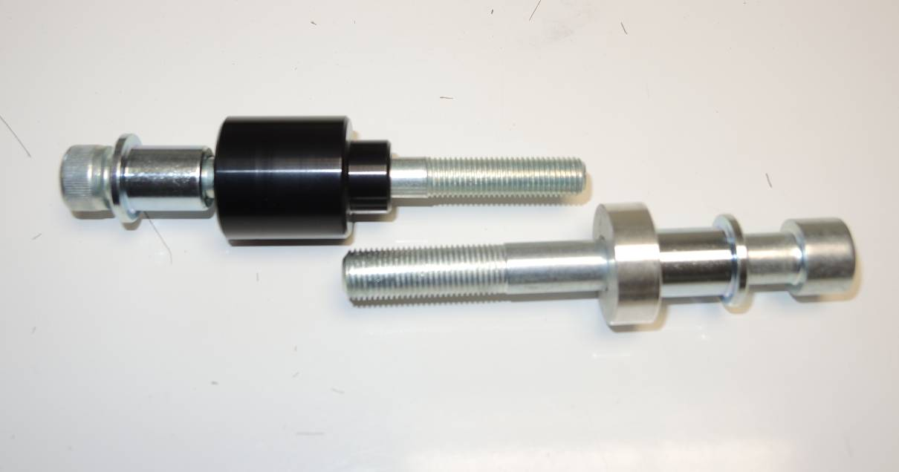
3
1
2

2
1
3

