Y9-2
Yamaha R1 2004-2006

Kit for left side: Kit for right side:
ID | Description | Cat.N | QTY
1 | Steel box M10 | X1 | 1
2 | Bolt M10x120x1,25 | 895 | 1
3 | Dural.cylind. d=62,5 | 498 | 1
ID | Description | Cat.N | QTY
1 | Steel box M10 | X1 | 1
2 | Bolt M10x120x1,25 | 895 | 1
3 | Dural.cylinder d=55 | 407 | 1

3
1
3
2
2
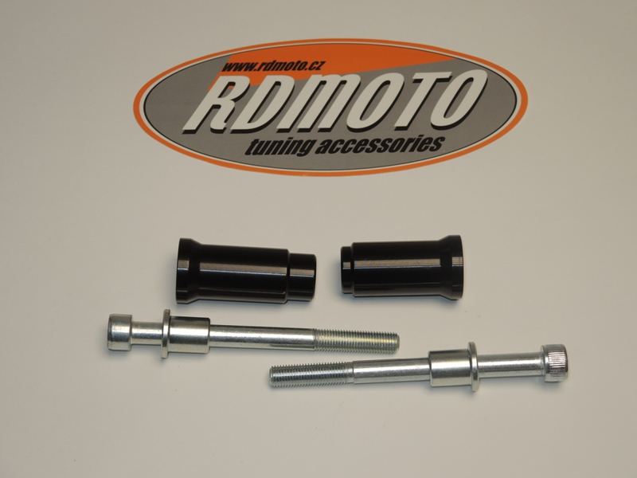
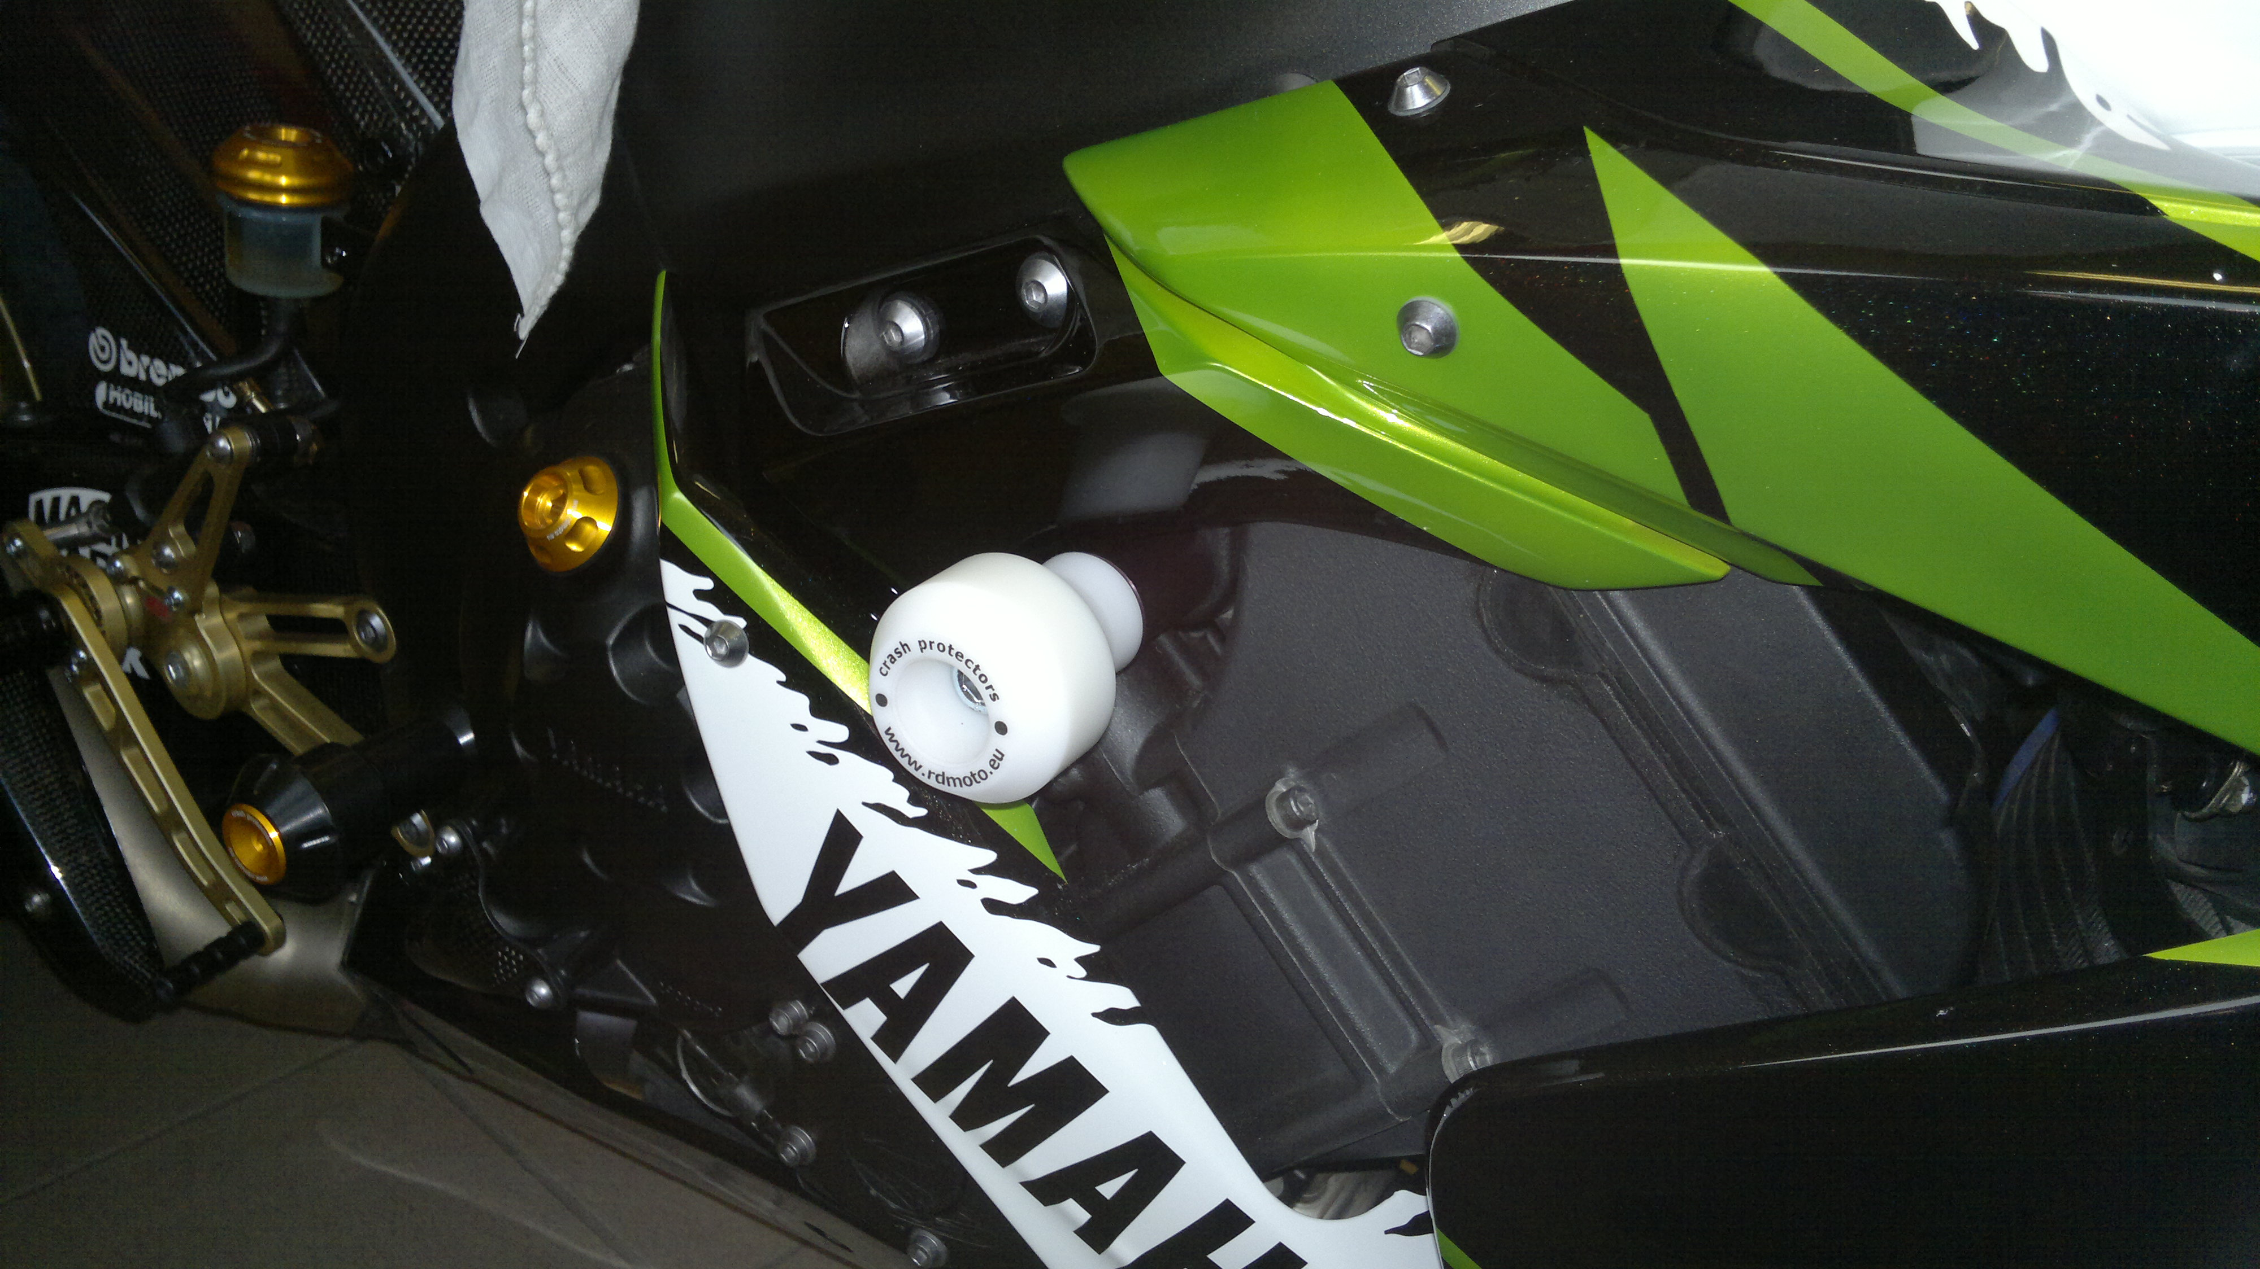
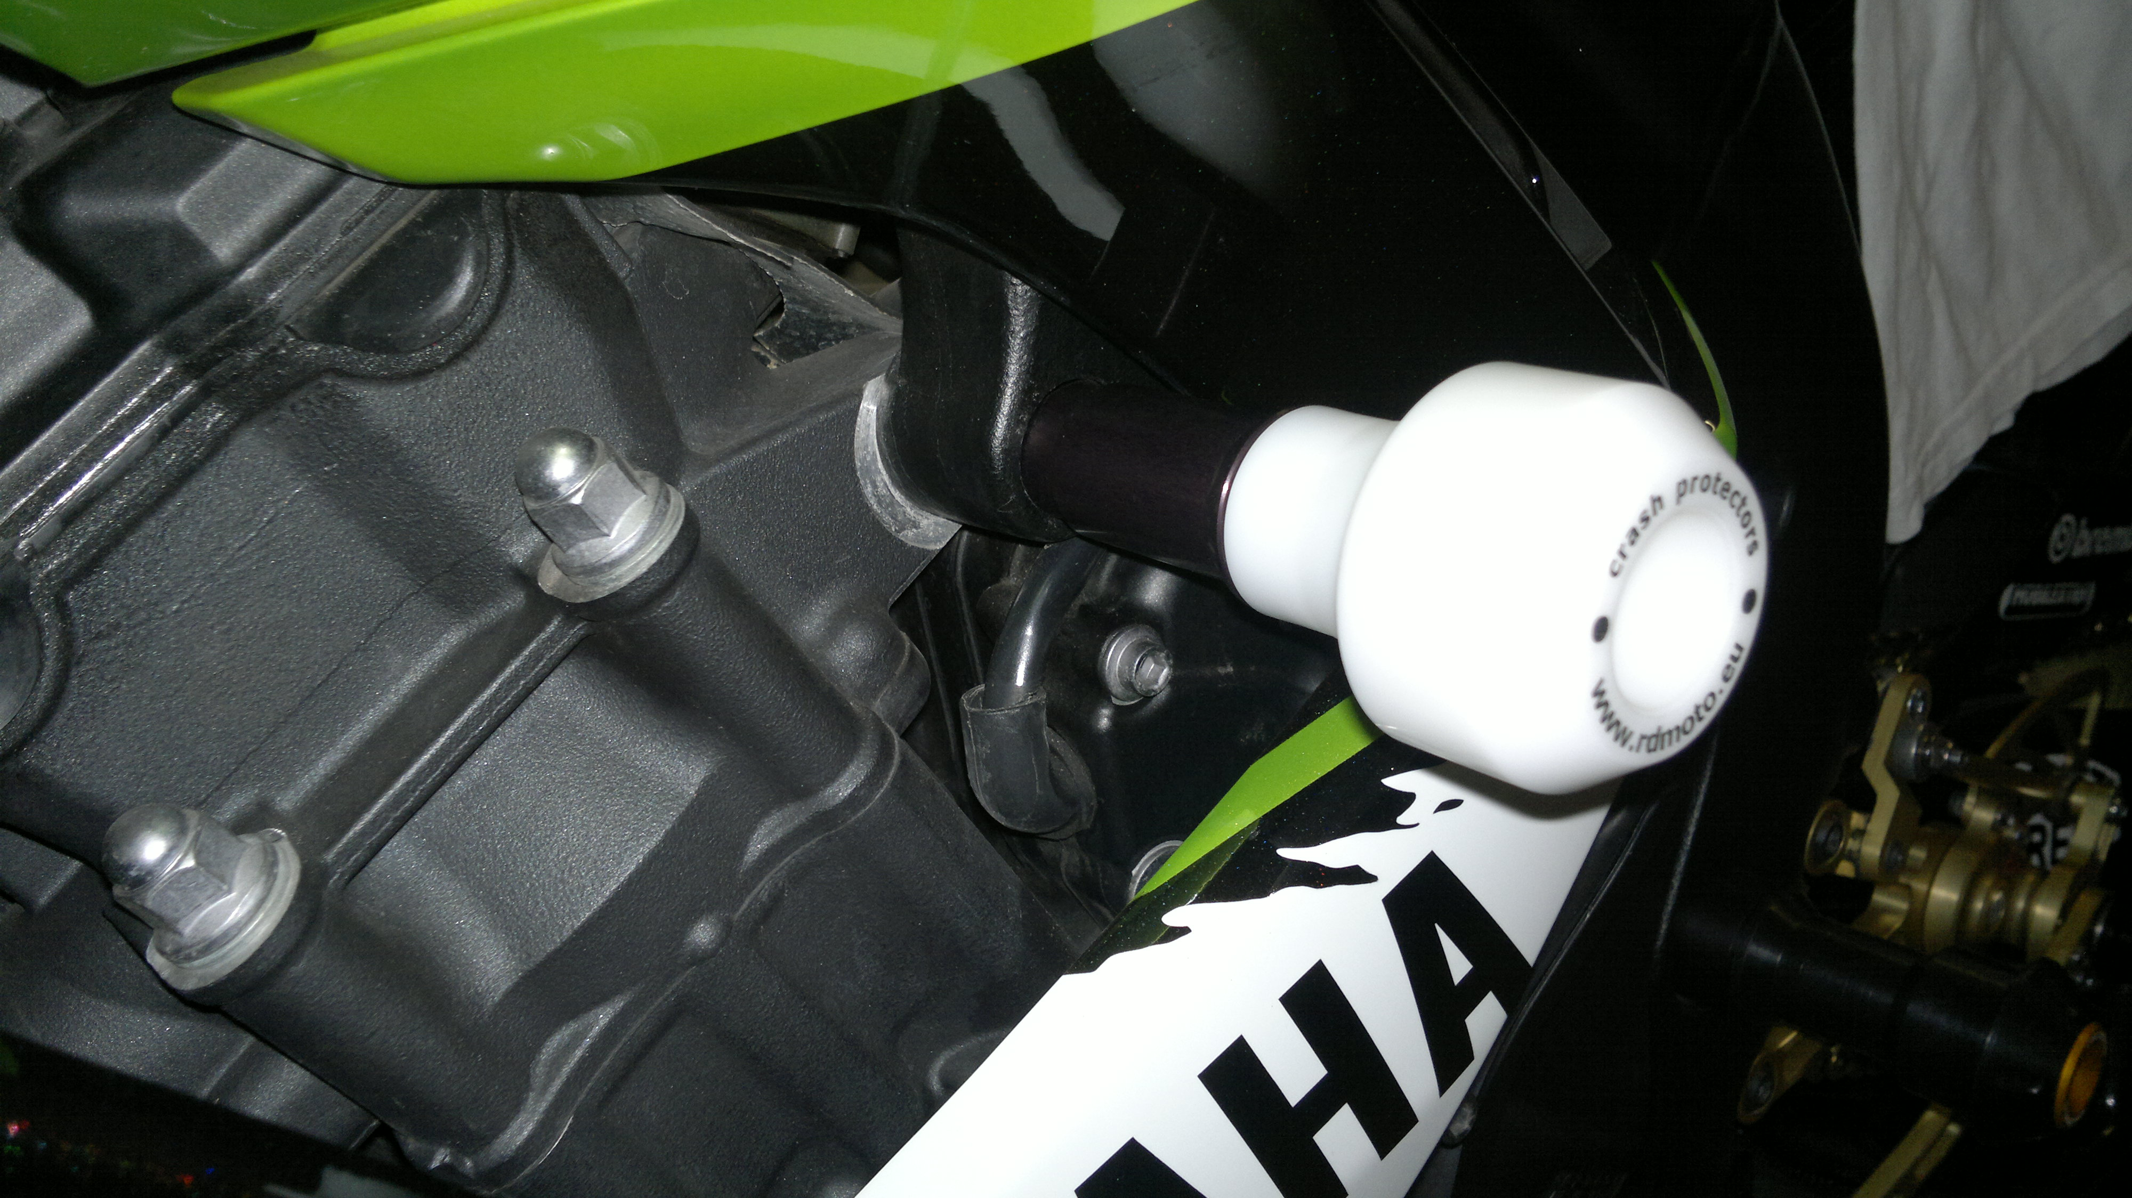
1
Instruction to assembly:

- The first do assembly left side.
- Take the protector for left side, insert steel box ID.1 into the protector.
- Insert bolt through the protector and after insert dural.cylinder ID.3 on the bolt.
- This kit gripping on the frame, replace original bolt M10.
- Mounting instruction for right side is same so left side.

Warning: We recommend use the glue of all threads. Medium strong.

2
1
2
3
1
3

