Y9SD
Yamaha R1 2004-2006

Left Side Fitting Kit: Right Side Fitting Kit:
ID | Description | Cat.no. | Ks
1 | SLD adapter | 537 | 1
2 | Dural. cylinder 40 mm | DV12 | 1
3 | Bolt M10x60 | 850 | 1
4 | Washer M8 | 800 | 2
5 | Bolt M8x25 | 815 | 2
6 | Dural. adapter | 583 | 1
7 | Bolt M10x70x1,25 | 898 | 1
8 | Dural. cylinder 16,5mm | 106 | 1
9 | Washer M10 | 804 | 1
10 | Plastic cap | X4 | 1
11 | 3M tape | 3M | 1
ID | Description | Cat.no. | Pcs
1 | SLD adapter | 537 | 1
2 | Dural. cylinder 30 mm | DV11 | 1
3 | Bolt M10x60 | 850 | 1
4 | Washer M8 | 800 | 2
5 | Bolt M8x25 | 815 | 2
6 | Dural. adapter | 582 | 1
7 | Bolt M10x100x1,25 | 892 | 1
8 | Dural. cylinder 27,5mm | 107 | 1
9 | Washer M10 | 804 | 1
10 | Plastic cap | X4 | 1
11 | 3M tape | 3M | 1

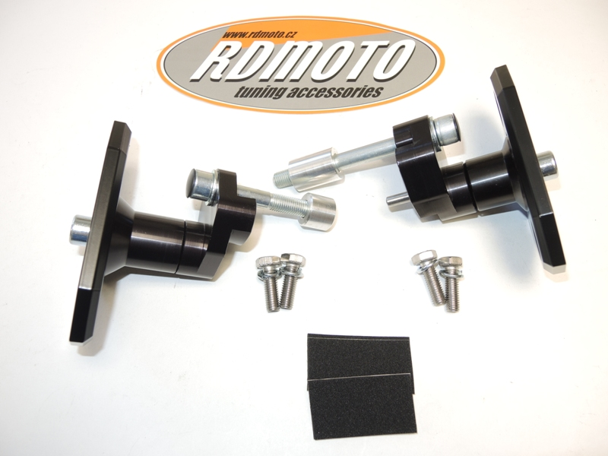
1

7,9,10
3
1
7,9,10
8

3

6
8
2

2
6
4,5
4,5

11

Instructions for the left side:

- Remove original bolt M10 from the frame.
- Stick 3M tape on the frame of motorcycle to prevent damage from adapter.
- Prepare bolt ID7 and washer ID9 and put bolt with washer through the adapter ID6.
- Put cylinder ID8 on the bolt (between frame and adapter). Put adapter on the frame and tighten it. Place plastic cap ID10 on the bolt.
- Prepare bolt ID3 and put SLD adapter ID1, cylinder ID2 on it. Fit this kit into the adapter ID6.
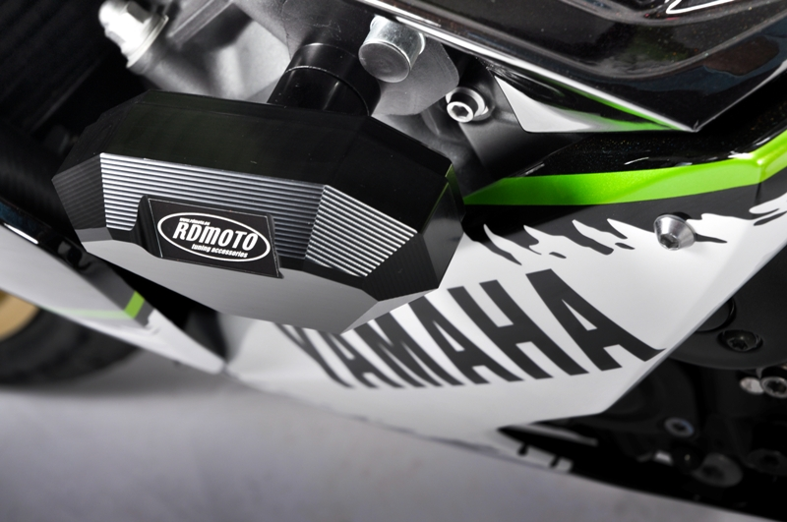
- Fit slider from back side using two bolts ID5 and washers ID4.

We recommend to use the glue on all threads (blue color – medium strong).

