Y9S
Yamaha R1 2004-2006

Kit for left side: | Kit for right side:

ID. | Description | Cat.N | Qt |  | ID. | Description | Cat.N | Qt
4 | Alu. adapter for SL01 (spacer) | DV-316 | 1 |  | 4 | Alu. adapter for SL01 (spacer) | DV-317 | 1
7 | Bolt M6x25 | 877 | 3 |  | 7 | Bolt M6x25 | 877 | 3
9 | Bolt M4x16 | 876 | 2 |  | 9 | Bolt M4x16 | 876 | 2
10 | Bolt M10x70x1,25mm | 898 | 1 |  | 10 | Bolt M10x100x1,25mm | 892 | 1
11 | Alu. spacer d=16,5mm | 106 | 1 |  | 11 | Alu. spacer d=27,5mm | 107 | 1
12 | Dural. protector holder | 583 | 1 |  | 12 | Dural. protector holder | 582 | 1
14 | Plastic cover | X4 | 1 |  | 14 | Plastic cover | X4 | 1
15 | 3M tape |  | 1 |  | 15 | 3M tape |  | 1
16 | Bolt M10x30 | 882 | 1 |  | 16 | Bolt M10x30 | 847 | 1
17 | Washer M10 | 804 | 1 |  | 17 | Washer M10 | 804 | 1

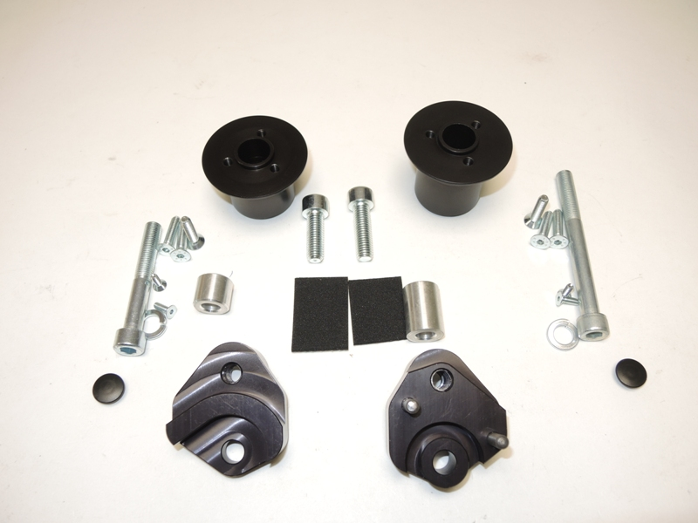

4
4

16
10
7
10

7
11
9
11
9

14
14

17
17

12

12

Assembly- left side:

- Remove the original bolt M10.
- Bolt ID.10 insert into the dural. adapter ID.12 with washer ID.17, place alu. spacer ID.11, stick 3M tape on the frame, where is adapter touching with chassis.
- Place plastic cover ID.14.
- Adapter for slider ID.4 tighten by bolt ID.16 on the milled dural. bracket.
- Place slide rand use bolt ID.7 insert alu. cover and tighten it by bolts poz.9.

Assembly- right side:

- Remove the original bolt M10.
- Bolt ID.10 insert into the dural. adapter ID.12 with washer ID.17, place alu. spacer ID.11, stick 3M tape on the frame, where is adapter touching with chassis.
- Place plastic cover ID.14.
- Adapter for slider ID.4 tighten by bolt ID.16 on the milled dural. bracket.
- Place slide rand use bolt ID.7 insert alu. cover and tighten it by bolts poz.9.

Warning- we recommand to use glue of threads during assembly. Medium strong.




