Y9
Yamaha R1 2004-2006

Kit for left side: | Kit for right side:

ID. | Description | Cat.N | Qt |  | ID. | Description | Cat.N | Qt
7 | Steel box | X1 | 1 |  | 7 | Steel box | X1 | 1
8 | Bolt M10x60 | 850 | 1 |  | 8 | Bolt M10x60 | 850 | 1
9 | Alu.spacer d=20mm | DV2 | 1 |  | 9 | Alu.spacer d=10mm | DV1 | 1
10 | Bolt M10x70x1,25mm | 898 | 1 |  | 10 | Bolt M10x100x1,25mm | 892 | 1
11 | Alu. spacer d=16,5mm | 106 | 1 |  | 11 | Alu. spacer d=27,5mm | 107 | 1
12 | Dural. protector holder | 583 | 1 |  | 12 | Dural. protector holder | 582 | 1
14 | Plastic cover | X4 | 1 |  | 14 | Plastic cover | X4 | 1
15 | 3M tape |  | 1 |  | 15 | 3M tape |  | 1
17 | Washer M10 | 804 | 1 |  | 17 | Washer M10 | 804 | 1

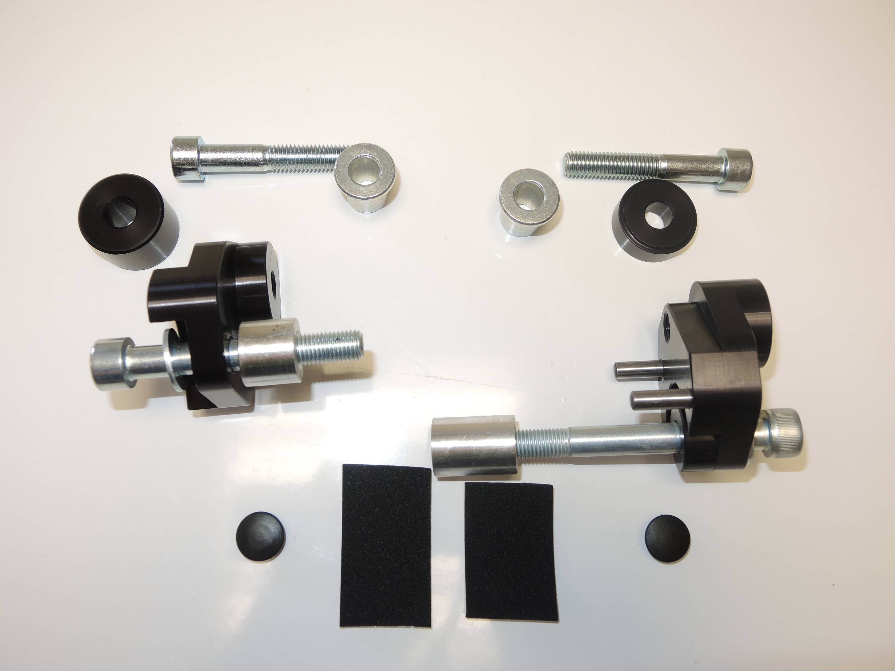

7
8
7
9
8

9

11
10

10
11

12

12
17
17
14

14
15

Assembly- left side:

- Remove the original bolt M10.
- Bolt ID.10 insert into the dural. adapter ID.12 with washer ID.17, place alu. spacer ID.11, stick 3M tape on the frame, where is adapter touching with chassis.
- Place plastic cover ID.14.
- Place steel box ID.7 into the protector. Insert bolt ID.8.
- Under the protector place alu. spacer ID.9.

Assembly- right side:

- Remove the original bolt M10.
- Bolt ID.10 insert into the dural. adapter ID.12 with washer ID.17, place alu. spacer ID.11, stick 3M tape on the frame, where is adapter touching with chassis.
- Place plastic cover ID.14.
- Place steel box ID.7 into the protector. Insert bolt ID.8
- Under the protector place alu. spacer ID.9.

Warning- we recommand to use glue of threads during assembly. Medium strong.
(ilustr. photo, place for fitting kit)

